Please follow these steps to activate your Azure Pass.

Browse to this location in order to claim your Azure access.

<https://www.microsoftazurepass.com/>

Creating a Microsoft Azure Pass Subscription

Creating an Azure Pass subscription is a two step process.

1. Redeem your Azure Pass Promo Code
2. Activate your subscription

Step 1: Redeeming a Microsoft Azure Pass Promo Code:

Open a browser and navigate to: www.microsoftazurepass.com

It is recommended you close all browsers and open a new In-Private Browser session. Other log-ins can persist and cause errors during the activation step.

Click the start button to get started.

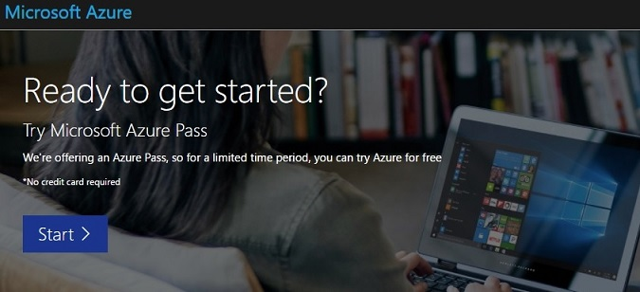

Enter your account login information and select “Sign In”.

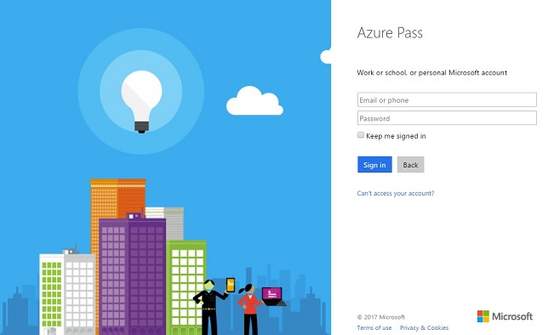

Click “Confirm” if the correct email address is listed.

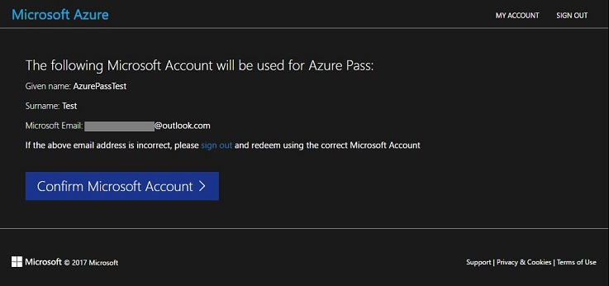

Enter your promo code in the Promo code box and click “Claim Promo Code”.

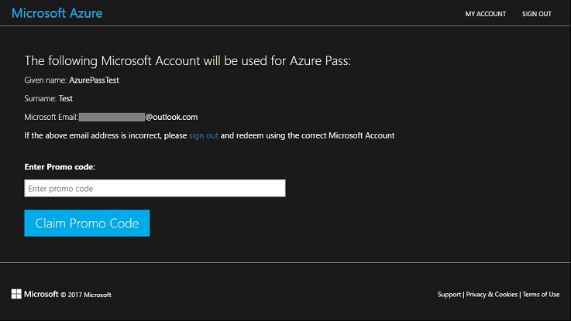

It may take up to 5 minutes to process the redemption.

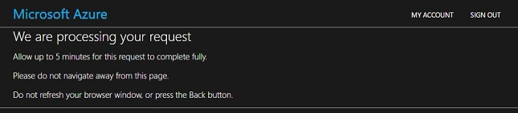

Click on “Activate” to start setting up your Azure subscription.

